CORE VALUES
Cub Scout Roundtable Leaders’ Guide
The core value highlighted this month is:
The core value highlighted this month is:
- Positive Attitude: Being cheerful and setting our minds to look for and find the best in all situations. Through participating in a derby, boys will see the importance of having a positive attitude, regardless of the outcome of the race.

COMMISSIONER’S CORNER
Pow Wow Books needed (REALLY NEEDED) I need ideas for Baloo for the Core Values. This month is mainly Pinewood Derby not Positive Attitude. Please help. Thanks to Jim, Pat and Bill, I have Great Salt Lake, Baltimore and Cascade Pacific.
I am looking for different ways to present achievements. So if you have come up with ideas for den meetings centered on the achievements & electives, please email them to davethecommish@gmail.com so we can include them in Baloo. And if you have good ideas for Character Connections, please email those, too.
Well it has been quite a month at Lake Woebegon. OOops, that is Garrison's line not mine. Two camping Trips, Wood Badge staff weekend, RV decided to leak gasoline, and much more. Enjoy Baloo and have a great holiday season.
TABLE OF CONTENTS
In many of the sections you will find subdivisions for the various topics covered in the den meetings
CORE VALUES 1
COMMISSIONER’S CORNER 1
THOUGHTFUL ITEMS FOR SCOUTERS 1
TRAINING TOPICS 2
ROUNDTABLES 2
PACK ADMIN HELPS - 2
LEADER RECOGNITION, INSTALLATION & MORE 2
DEN MEETING TOPICS 2
SPECIAL OPPORTUNITIES 3
Duty to God Promotion Patch 3
Religious Emblems 3
FAQs about Religious Emblems 4
Knot of the Month 5
GATHERING ACTIVITIES 5
OPENING CEREMONIES 6
AUDIENCE PARTICIPATIONS 6
ADVANCEMENT CEREMONIES 6
GAMES 6
SONGS 8
STUNTS AND APPLAUSES 9
"Applauses & Cheers, Run-Ons, and 9
SKITS 9
CLOSING CEREMONIES 9
Cubmaster’s Minutes 9
CORE VALUE RELATED STUFF 9
DEN ACTIVITIES 9
DEN MEETINGS 14
TIGER 14
WOLF 14
BEAR 15
WEBELOS DENS 15
Core value for February Resourcefulness 15
Meeting Planner 17
Flag Ceremony 17
Den Meeting Helpers 18
Webelos 18
Engineer 18
Arrow of Light 23
Handyman 23
Sportsman 25
ADDITIONAL ADVANCEMENT IDEAS 27
CUB GRUB 27
POW WOW EXTRAVAGANZAS 28
WEB SITES 28
ONE LAST THING 29

THOUGHTFUL ITEMS FOR SCOUTERS
The "Thoughtful Items" and "Quotations" are in the Pack and Leader Hints Edition Dave

TRAINING TOPICS
Learn about the Resources that your council and district use to help you succeed. The "Training Topics" are in the Pack and Leader Hints Edition Dave

ROUNDTABLES
The "Roundtable Hint" is in the Pack and Leader Hints Edition Dave

PACK ADMIN HELPS -
Be sure to check out the item on a great resource, "Den Chiefs" in "Pack Admin Helps " this month. It is in the Pack and Leader Hints Edition Dave

LEADER RECOGNITION, INSTALLATION & MORE
The "Leader Recognition" section is in the Pack and Leader Hints Edition Dave

DEN MEETING TOPICS
Wendy, Chief Seattle Council

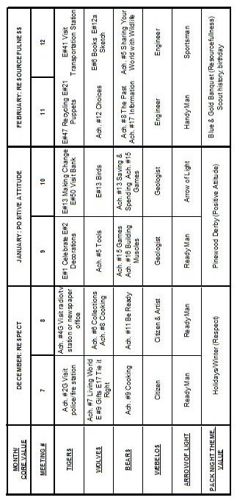
From Bob Scott at National in answer to my question on the role of Roundtables with the new delivery system -
Dave, you have it right.
No changes to roundtable’s role, how it's executed, etc.
Bob Scott , Innovation Coordinator - CS 2010

SPECIAL OPPORTUNITIES

Duty to God Promotion Patch
P.R.A.Y.
www.praypub.org
I have attended the Religious conferences at the Philmont Training Center twice. Mark Hazlewood, the Director of P.R.A.Y., led one conference and helped at the other. It was great being with so many Scouters who wanted to help Scouts fulfill their Duty to God and strengthen their faiths. Mark and the organization at P.R.A.Y. have done a great job setting up this promotion effort. Their website and the DVD have everything – scripts, slideshows, FAQs, and other stuff. Lets get out there and make a difference. CD
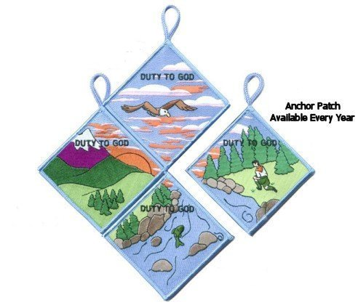
Patch Availability
August 2010-July 2011: Fish
August 2011-July 2012: Eagle
August 2012-July 2013: Mountain

“Duty to God” is at the heart of the Scouting movement. Religious emblems reinforce this spiritual component and promote many of the values found in the Scouting program. The purpose of this “Duty to God Promotion Patch” is to encourage youth and adults to learn about and promote the religious emblems programs.
Requirements –
Youth and adults must:
- Attend or coordinate a presentation or information seminar on religious emblems (sample resources and suggestions are available at www.praypub.org ).
- Make a commitment to fulfill their “Duty to God.”
Here are some examples:
- Adults can commit to having 50% of families participate in the religious emblems programs, nominating a worthy adult to be recognized with an adult religious award, serving as counselor in their local congregation, etc.
- Youth can commit to earning the religious emblem of their faith at an appropriate time, making a presentation on religious emblems to another unit, helping younger Scouts earn their religious emblem, etc.
The Patch
- The Duty to God Promotion Patch is a four-segment puzzle patch.
- Only one segment will be offered in any given year.
- Participants are encouraged to earn all four segments over a four-year span.
- Visit www.praypub.org to find out which patch is currently available.
- Patches may be pre-ordered for distribution at the presentation/ information seminar.
The DVD
The Duty to God Promotion DVD contains the resources to make a presentation on the religious emblems programs. These resources include the video “Promoting Duty to God (Religious Emblems),” Duty to God brochure/chart listing all religious emblems (No. 05-879), scripts (for presentations to Cub Scouts, Boy Scouts, and Venturers), and Parent Handout.
Making a Presentation
- Find scripts, videos, handouts, and other resources at www.praypub.org
- Invite parents
- Provide information on emblems of ALL faiths
- Encourage Scouts to make a commitment to earn their religious emblem
- Present the Duty to God Promotion Patch to participants
Call and talk to the "Religious Emblems People" today!
1-800-933-7729 or visit them at www.praypub.org

Religious Emblems
www.USScouts.org
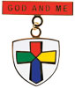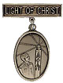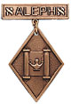
"A Scout is Reverent." All Scouts show this by being faithful in their duty to God. Some go further and give special service. This can qualify them for a religious emblem. Such an emblem is not a Scouting award. It is conferred on a Scout by his religious leader. Each faith has its own requirements for earning its emblem. Listed below are the BOY SCOUT and VARSITY SCOUT emblems and where to find out about them. Before writing or visiting your local council service center, check with your religious leader.
(Unless indicated otherwise below, awards listed may be earned by both Boy Scouts and Varsity Scouts.) Older Boy Scouts of Varsity Scout age (over 14), Venturers, and Sea Scouts (and in some cases, Explorers) are eligible for any awards that Varsity Scouts may earn.
Most of these groups also offer religious emblems for younger youth in the various Cub Scout Programs. For information on the awards available to Tiger Cubs, Cub Scouts, and/or Webelos Scouts. Click Here or got o http://usscouts.org/advance/cubscout/religious.asp .
Most of the awards consist of bar pins, ribbons, and pendants, and are worn on the uniform above the left pocket on formal occasions. In addition, the Religious Emblem Square knot, shown at the top of this page, may be worn on the uniform over the left pocket by youth or adults who earned any of the religious awards. One or more miniature devices are affixed to the knot to indicate which level(s) of the award was earned. For more information on the Youth Religious Emblem square knot patch go to http://usscouts.org/advance/cubscout/religious.asp#Chart or http://www.scouting.org/scoutsource/Awards/ReligiousAwards/chart.aspx. For information on the devices which are attached to the knot, Click Here or go to http://usscouts.org/awards/devices.asp.

FAQs about Religious Emblems
www.scouting.org
What are the religious emblems programs?
The religious emblems programs are programs created by the various religious groups to encourage youth to grow stronger in their faith. The religious groups—not the Boy Scouts of America—have created the religious emblems programs themselves. The Boy Scouts of America has approved of these programs and allows the recognition to be worn on the official uniform, but each religious organization develops and administers its own program.
I have a unit with children of all different faiths. How can I include the religious emblems programs for my unit?
The religious emblems programs should be presented to youth members and their families as an optional program for them to complete through their religious organization. Religious instruction should always come from the religious organization, not from the unit leader. Parents need to be informed of these programs and told where to get the information for their particular faith. Interested in making a presentation on the religious awards? Find sample scripts at www.praypub.org.
Do boys and girls participate in the same program?
It depends on the religion. Some religions have created programs that are used by both boys and girls. Other religions have created programs for members of separate youth agencies (i.e., Boy Scouts of America, Girl Scouts of the U.S.A., and Camp Fire Boys and Girls). Please check the specific eligibility requirements for each religious emblems program.
Do the youth have to belong to a religious institution?
It depends on the religion. Please check the eligibility requirements for your particular religious program.
Why doesn't my religious institution know about the religious emblems programs?
Although the religious bodies at the national level created the religious emblems programs, the local religious institution may not be aware of these programs. It may be helpful to write for more information or even obtain a copy of the curriculum to give to your religious leader.
If the religious emblems program for my faith has more than one level (for the different grade levels), may my child earn all of these recognitions?
Yes. Members can earn all levels of their religious emblems program. However, they must be in the appropriate program guidelines when they start and complete each level (they may not go backward and earn younger programs).
How is the emblem presented?
The emblem should be presented in a meaningful ceremony, preferably in the youth member's religious institution. Some emblems come with a sample presentation ceremony.
How long does it take to complete a program?
It depends on the program. Some programs may take three or four months, others longer.
Where is the emblem worn on the uniform?
The universal religious square knot is worn over the left shirt pocket of the Scout uniform. The medallion is pinned over the square knot for full uniform occasions.
How do we get started on these programs?
- Youth members must obtain the specific booklet for their religion. This booklet will contain information on all the lessons and service projects that they will need to complete. Each member needs to have his or her own booklet to document progress. Some religions also provide adult manuals for counselors and mentors. Check with your local council to see if it stocks these booklets in its store, or contact the religious organization directly (addresses and phone numbers are provided at http://www.scouting.org/scoutsource/Awards/ReligiousAwards/~/link.aspx?_id=9D5FA10AEB254061A248D13D459424FE&_z=z).
- Parents must review the specific guidelines for their particular program; age/grade requirements vary from program to program. Some programs require that the youth be an official "member" of the local religious institution, others may not. Each program determines who may serve as counselor (some require clergy, others allow parents or other family members). Be sure to look at specific eligibility guidelines!
- Families should talk to their religious leaders and show them the booklet before beginning any program. Most of the religious emblems programs require that they be completed under the auspices of that religious organization, and many require the signature of the local religious leader. Again, check the specific eligibility requirements for your religious program.
- The member needs to complete the requirements, obtain the proper signatures, and follow the instructions to order the emblem/award. (These emblems are not available in your local council.) The emblem can be presented at any time of the year and should be presented in a meaningful ceremony, preferably in the member's religious institution.
Who may serve as counselor?
It depends on the program. Some programs require clergy to serve as counselor, others allow a parent or family member. Please check the specific guidelines for your religious program.
How do I order the recognition items?
Each religious program has its own emblem. Follow the instructions in your recognition guidelines because the emblems come from different places and require submission of different information. These emblems will not be available in your local council!
What is the adult religious recognition program?
An adult religious recognition award is presented by nomination only. The recognition is presented to worthy adults for their outstanding service to youth both through their religious institution and one of the national youth agencies. Recipients of these awards are unaware that they are being nominated. They are nominated to receive an award by submitting the required application, letters of recommendation, and resume. Please check eligibility requirements for specific awards.
Which religious emblem square knot should I wear?
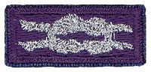
Cloth, silver knot on purple, No. 05007, may be worn by youth or adult members who earned the knot as a youth, above left pocket.
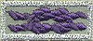
Cloth, purple on silver, No. 05014, may be worn by adult members presented with the adult recognition of a faith, above the left pocket. Adults may wear both knots if they satisfy qualifying criteria. (See the Insignia Guide, No. 33066D.)

NOTE: - Since the programs are similar or the same (as in the case of the PRAY Awards) for girls and boys in Boy Scouting, 4H, Girl Scouting, Campfire, etc., a female Venturer or Adult Leader who earned her religious award as a youth may wear the purple square knot on her uniform even though it was not earned as a member of the BSA.(My daughter Darby in New Mexico does this!!)
Per Mike Walton of www.USScouts.org, this applies to BOTH MALES AND FEMALES, youth and adult. If you earned a youth religious emblem as a youth member, whether or not it was earned or received as a BSA member does not matter. The youth religious emblem square knot represents ANY AWARD which youth members earned or received -- period.
So yes, a Girl Scout, 4Her, or Royal Ranger/Missionette who earned a youth religious emblem in those programs and then either becomes an adult or youth member of the BSA (to include Venturing/Sea Scouting) may wear that emblem formally with the BSA's field uniforms; and informally wear the square knot insignia on the uniform shirt.
Mike says he has been told when the next edition of the Uniform Guide for 2012 is printed, there will be text explaining this on the page which shows all of the various youth religious emblems.CD

Knot of the Month
See The "Knot of the Month" in the Pack and Leader Hints Edition for information on Adult Religious Awards/Recognitions
Dave

GATHERING ACTIVITIES
"Gathering Activities" for large groups and getting groups to know each other are in the Pack and Leader Hints Edition. Those good for dens (e.g. word searches, puzzles, mazes) are here. Dave
Note on Word Searches, Word Games, Mazes and such – In order to make these items fit in the two column format of Baloo’s Bugle they are shrunk to a width of about 3 inches. Your Cubs probably need bigger pictures. You can get these by copying and pasting the picture from the Word version or clipping the picture in the Adobe (.pdf) version and then enlarging to page width. CD
The Cub Scout Promise &
Law of the Pack
Great Salt Lake Council
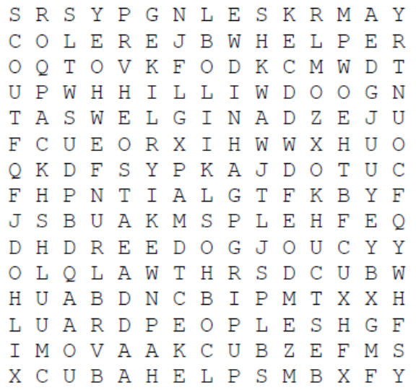
Fill in the blanks and then find the words. Each missing word can be found in the puzzle.
The Cub Scout Promise
I ------- to -- my ----
To do -- ---- to --- --- my -------,
To ---- ----- ------, and
To ---- the --- of the ----
The Law of the Pack
The Cub ----- ------- -----
The --- Scout ----- the pack go
--- pack ----- the --- Scout ----
The --- Scout ----- --------.
Webelos Maze
Cascade Pacific Council
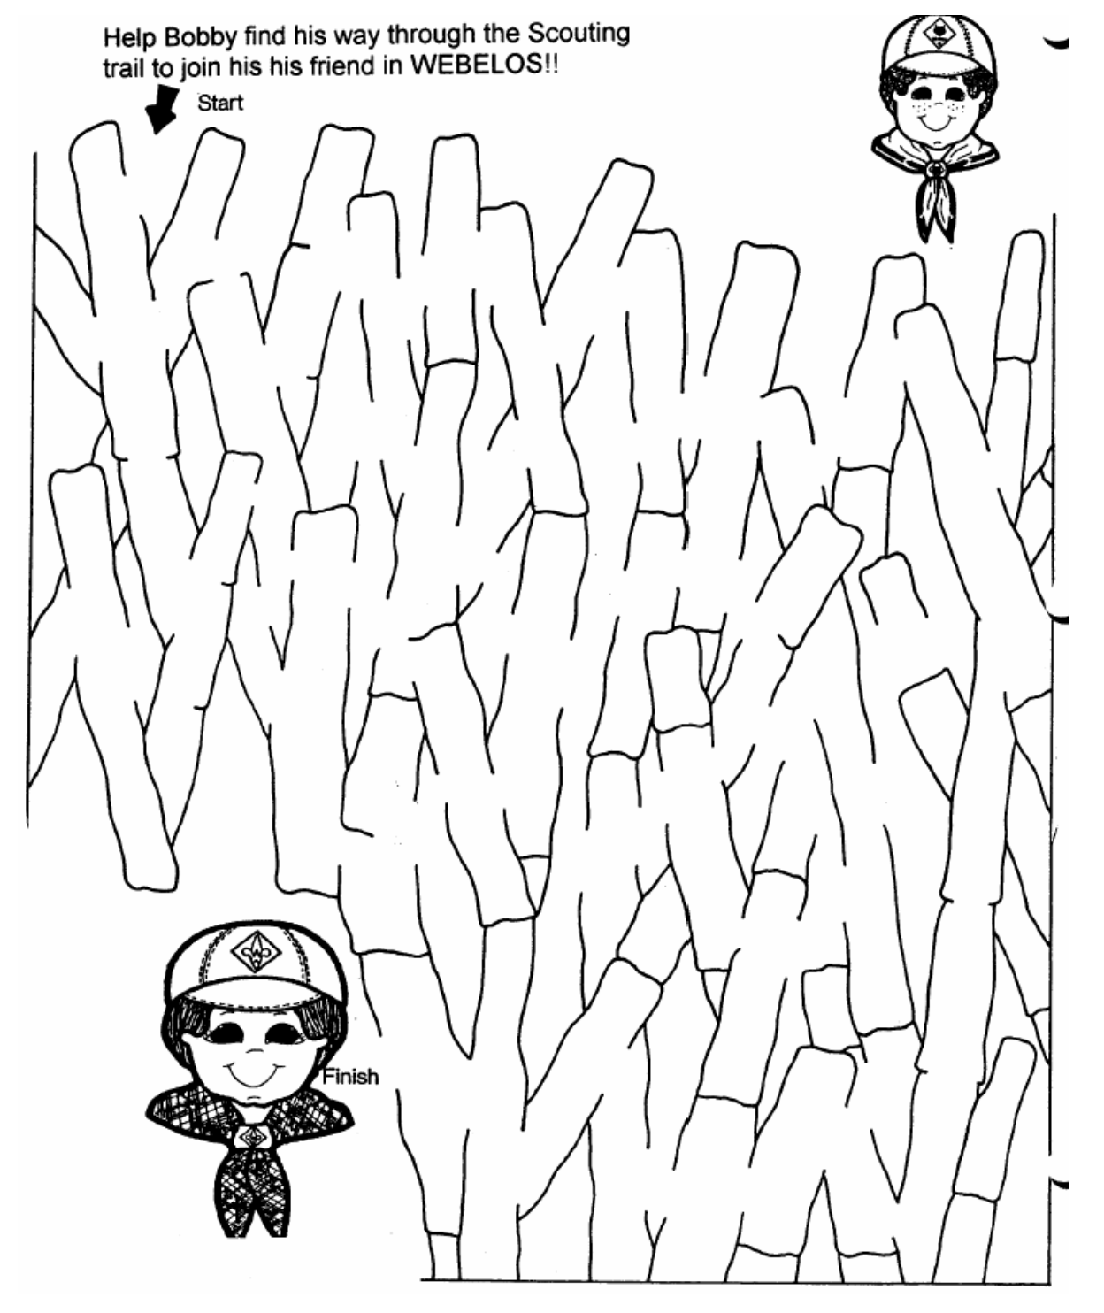

OPENING CEREMONIES
"Opening Ceremonies" are in the Pack and Leader Hints Edition Dave

AUDIENCE PARTICIPATIONS
"Audience Participations" are in the Pack and Leader Hints Edition Dave

ADVANCEMENT CEREMONIES

More "Advancement Ceremonies" are in the Pack and Leader Hints Edition Dave

GAMES
Picking Who Is It
Great Salt Lake Council
Den Level -
Make it a job on a den job chart. The responsibility can be used as a reward for the boy who came the most prepared for the den meeting or for the boy who is on his best behavior for that day. For team picking, line the boys up chronologically and then assign numbers. It gives a good mix to the group.
Pack Level -
At pack meetings, the boy/s whose birthday it is that month or a boy who has advanced that month may have the opportunity to assign or be “it”. If playing team sports as a pack, try to insure that each den is represented on each team rather than the wolves against the Webelos. This makes for better-balanced teams.
Find Baden-Powell
Cascade Pacific Council
Pick one player to be Baden-Powell and give blindfolds to all other players. Baden-Powell slowly walks around the area. All blindfolded players walk around calling out "Baden-Powell" when they bump into someone. If they hear "Baden-Powell" in return, they keep searching; if they hear "My Scout", they remove their blindfold and join Baden-Powell in the search for scouts. Game is over when Baden-Powell finds all of the scouts.
Pass It Along
Cascade Pacific Council
Line up in a straight line. The first player pretends to pick up an object and passes it to the next player, who continues to pass it in the same way until it reaches the end of the line. The person at the end must guess what the object is; if he can't, the next player up the line guesses, until finally, the person who started passing it tells what it was. (A baby would be picked up gently in the arms, a stone would show effort and strain, a pin would be picked up between the thumb and forefinger.) Divide into teams, if lots of players, and a leader would tell each team what to pretend picking up. •
Bean Pick Up
Cascade Pacific Council
Arrange the players around a table or kneeling in a circle on the floor. Give each a saucer with two toothpicks and 12 beans. On signal, see who can be the first to lift out five beans.
Catch A Bear, Wolf, Or Etc.
Cascade Pacific Council
Equipment: cup, cut out figures of bears, wolves or etc. Cut out figures you want to use. They must fit into the cup. Place numbers on the figures.
Play: Players all toss several figures in the air and try to catch them with the cup. Add the numbers on the figures caught.
Stick in the Bottle
Cascade Pacific Council
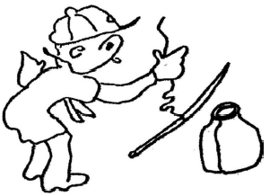
Attach 30” of string to an 18” stick. While holding the string, drop the stick so one end bounces on the floor. Then guide the other end into a quart-sized bottle. It works fine ... sometimes.
Trust Tag
Cascade Pacific Council
This game is played like regular tag, except that the players play in groups of two. One partner must wear a blindfold. His teammate guides him by keeping his hands on his blindfolded partner’s waist and shouting directions. The object is for the blindfolded player to tag another blindfolded player.
Wagon Wheels
Cascade Pacific Council
A wagon wheel is created by having about seven children facing each other and joining hands to form a circle. The wheel then moves in a circular motion around the walls of gym. Two or three children (the bottom of the wheel) have their backs touching the wall momentarily as the wheel spins along the wall. The fun increases as the wheel picks up speed. Try putting the wheel into reverse or changing the speed.
Pass the Baton
Cascade Pacific Council
Have the group form a circle. Give one person a baton-like item, such as a paper towel roll. Have the group members say the words of the Pledge of Allegiance, a song, cheer, prayer, etc. The first person says the first word, and pass the baton to the person on his left. The second person says the next word, and passes the baton, and so on until someone makes a mistake.
If a mistake is made, that person steps out of the circle. The next person says the correct word, and play continues until only one person is left. Repeat the game with the Cub Scout Oath, or a new song or prayer.
Alphabet Pong
Cascade Pacific Council
This is a good game for a den activity. Have the boys from a circle, with each boy holding a book (hardcover) with both hands. One player takes a ping-pong ball, hits it with the book across the circle, and calls, “A.” The person on the other side then returns it to someone and calls, “B,” and so forth. The circle works together to see how far down the alphabet then can go before they miss. There is no particular order for hitting the ball. Anyone can hit the ball when it comes to him or her, but no one may hit the ball twice in a row.
Blind Volleyball
Cascade Pacific Council
Split the boys into two equal teams. The two teams then get on each side of a volleyball court and sit down either on chairs or on the floor in rows, arranged like regular volleyball. Hang a blanket over the net so that a solid barrier is form and obstructs the view of the other team. The divider should also be low enough that players cannot see under it. Then play volleyball, using a big, light plastic beach ball instead of a volleyball. Regular volleyball rules and boundaries apply. A player cannot stand up to hit the ball.
Ping-Pong Ball Relay
Cascade Pacific Council
This is a good party game for a den meeting. Give the boys a ping-pong ball and a party blower (the type that uncoils when you blow it), and have them line up at the starting line. Each boy is to push their ball across the floor using only their blower. He cannot blow directly on the ball or touch it in any way with the party blower. The first one across the finish line wins.
Ball, Basket and Board
Cascade Pacific Council
Carry a ball across the room on a three foot long board. Drop it in a basket.

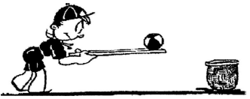
Clip It
Cascade Pacific Council
Each table has a small dish filled with paper clips. On a signal, the first person joins two paper clips together and passes the bowl and beginning of the chain to the next person. That player adds another clip to the chain and passes it on. Continue in a circular fashion. After a pre-determined time (five to eight minutes), hold the paper clip chains high in the air—the team with the longest chain wins.
One Foot Up
Cascade Pacific Council
Players are divided into two teams. Two goal lines should be drawn about twenty feet apart. Each team stands behind its own goal line. At a signal, both teams advance hopping on one foot. The object is for the player to reach and cross the opposing team's goal line without setting his other foot on the ground. The boys try to unbalance one another by butting with their shoulders. The team that gets the most players over the opponents goal line wins.
A Good Pick-up
Cascade Pacific Council
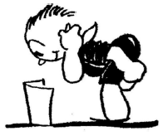
Hold your left ear with your right hand. Put your right foot behind your left knee. Bend over and pick up paper. This will require some hopping around. Shorten the paper each time you pick it up. Try it in reverse, by holding your right ear with your left hand, and putting your left foot behind your right knee.
Bottle-Filling Race
Cascade Pacific Council
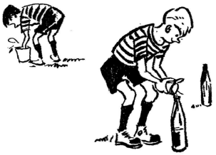
Each Cub Scout has a cup. An empty soda bottle is placed twenty feet in front of him and a can of water is placed behind him. On a signal, each boy must fill his cup with water, run to the soda bottle, and pour in the water. He runs back and forth between the can and the bottle until the bottle is full.
Shere Khan
Cascade Pacific Council
Play outside or in a large room. Have goal lines on opposite ends of the playing area. One of the players is Shere Khan, the tiger from Rudyard Kipling’s Jungle Book. He and all other players stand at one goal line. Shere Khan calls, “Who’s afraid of Shere Khan?” The other players shout, “No one!” and immediately race for the other goal. If Shere Khan tags one, he becomes a second tiger and joins in the next chase. Continue until all are caught.
Crocodile
Cascade Pacific Council
Half the den is on each side of the “river” in which the Crocodile lurks. The Crocodile calls for one particular player to try to cross the river. That player then calls for another on the opposite side to try to change places with him. While the two run, the Crocodile tries to tag on. If he succeeds, the tagged player becomes the new Crocodile; the game continues.
Cub Scout Uniform Game
Cascade Pacific Council
When preparing for a uniform inspection, have the denner slip in with his uniform rearranged in the following manner and let the Cub Scouts tell what is wrong.
- Cap on backwards
- Campaign button on cap
- Wearing den chief cord
- Service star on neckerchief
- Neckerchief twisted into a roll
- Neckerchief tied around the neck
- Belt buckle worn on one side.
- One sleeve rolled up
- Button unbuttoned
- Pocket turned inside out
Who’s the Leader?
Cascade Pacific Council
This campfire favorite can be played at home. One player is chosen to be IT and leaves the room. The other players sit in a circle. When the players have selected a leader, they invite IT to come back into the room. The leader then starts a motion, such as tapping his left hand on the floor. The other players imitate him. When IT isn’t watching him, the leader changes his motion, perhaps rubbing his right ear, and the other players follow. The object of the game is for IT to guess who is the leader in starting the motions.

SONGS
Resourcefulness
Great Salt Lake Council
Tune: London Bridges Falling Down (Samba)
With your mind, use what you’ve got,
It’s quite a lot, you’ve been taught,
and then turn it really hot –
Be resourceful.
Shape it blue, but give it zing,
make it fling, now your king!
Keep it moving and make it swing –
Be resourceful.
Change it up, wow look at me,
I am free, to let it be,
Now I’m playing in a minor key –
Living resourcefully.
Ode to a Leader
Cascade Pacific Council
A skit for the Den leaders and committee
(by Dee Engle)
One leader can sing or recite the verse or the adults can take turns. All the leaders and committee sing the chorus.
After raising six sweet daughters, I was glad to have a son.
I thought of all the games we’d play, the picnics, hikes and fun.
I thought of how we’d sit and talk for hours when day was done.
Wasn’t I the foolish one?
Chorus:
Glory, glory, I’m a leader!
How’d I get to be a leader?
All I wanted was to have a nice, quiet son.
Cub Scouting might be fun.
I tried to resist their pleas, their reasons to ignore.
I said, “I’m not equipped;” they said, ‘Oh, yes, you are!”
“We will train you in the basics we’ll outfit you for the corps.”
And they shoved me out the door!
(Chorus)
They taught me how to sing a song and how to tie a knot.
They taught me how to do a skit, make puppets on the spot.
They taught me all I’d need to know, at least that’s what I thought,
Till a Cub came in with a snake that he’d caught!
(Chorus)
We went out hiking, my Webelos Den and me.
They say the woods are full of many sights for you to see.
I know we sure were sights when we were found, eventually,
And I do this all for free!
(Chorus)
But even though I mumble and I grumble and I pout,
And many times I wonder what’s the best way to get out,
When all is said and done, there really Is no doubt
I’m glad to be a Scout!
Chorus:
Glory, glory, I’m a leader.
I’m so glad to be a leader.
And when they lay me down to my eternal rest
They’ll said I did my very best!

STUNTS AND APPLAUSES

"Applauses & Cheers, Run-Ons, and
Jokes & Riddles" are in the Pack and Leader Hints Edition Dave

SKITS
"Skits" for the Pack Meeting are in the Pack and Leader Hints Edition Dave

CLOSING CEREMONIES
"Closing Ceremonies" are in the Pack and Leader Hints Edition Dave

Cubmaster’s Minutes
"Cubmaster's Minutes" are in the Pack and Leader Hints Edition Dave

CORE VALUE
RELATED STUFF
Connecting Resourcefulness with Outdoor Activities
Wendy, Chief Seattle Council
(Adapted from B.A.L.O.O. Appendix E)
- Hikes - Take a "Search and Find" Hike. Look for different animal homes and discuss how resourceful they are in finding or making shelter.
- Nature Activities - Find NATURE everywhere - in a backyard, a puddle of water, a vacant lot, or a flowerpot. Examine different birds' nests and discuss how resourceful birds are in finding materials to use.
- Service Projects - Have the boys make a quilt from materials they glean from their closets (with parents' permission) or extra materials families have. Donate the quilt to a local shelter.
- Games & Sports - Play some problem-solving games. Have boys create their own game, or choose a pioneer style game or a game from another culture.
- Ceremonies - Point out the resourcefulness of a boy in accomplishing his advancements. Talk about prehistoric people and how they made tools from what they found. Note that we all must work with what we have.
- Campfires - Have boys build an "Indoor Campfire" for those times when they want a campfire setting but cannot be outdoors.
- Den Trips - Visit a recycling center. Visit a quilt shop and talk about the history of quilts - how early Americans used everything they had. Discuss how early Americans had to raise and grow all their food.
- Pack Overnighter - Have an indoor overnighter, playing board games, cards, or games the boys love or have made themselves.

DEN ACTIVITIES
Beyond the Badge - Field Trips
Great Salt Lake Council
Field trips can be a fun way to expose the cub scouts to different places and new things to learn. Some have fees but most are free. We have some wonderful suggestions for you and here are just a few, but I am sure they boys will have some great ones as well.
Bakery Energy Center Motor Sports Park
Soccer Store/Camp Food Bank Radio Station
TV Station Humane Society Animal Shelters
Dairy Fire Department Recycling Centers
History Museum Library Governors’ Mansion
Church Art Center Candy makers
Brick Companies Electric Company Gas Company
Aviary Pioneer Museums Sign Co.
Grocery Stores Planetarium Children’s Museum
Publishing Co. Soda Bottling Co. Wildlife Refuge
Special Parks Historical society College
State Capital Cruise/Sail Air Museum/Park
Local Industry Landfill Town Hall
Police Station Highway/Road Dept Bank
The possibilities are too numerous to mention. Plan ahead to see if it works for your group or if they offer this service. Please remember to call ahead and schedule as well if any fees are charged, and note contact information. Check out the websites of places you are interested in visiting for information on possible outings, there are many options. Ask around to other leaders for the places they found to be good outings, they can be a wonderful resource.
Maybe your council has a list of local trail and activity patches that are listed on their website that you can earn on your field trip. We have all heard the phrase KISMIF (Keep It Simple, Make It Fun) in the relation to cub scouting. This definitely applies to the field trips as well. Make it fun and interesting and they will return. HAPPY SCOUTING and don't forget your TOUR PERMIT.
Marbleized Stationary for Invitations
Baltimore Area Council
Materials:
Newspapers bucket water
white paper envelopes
stick, dowel or chopstick blue and gold spray paint
Directions:
- Cover the work area thickly with newspapers.
- Fill a bucket ¾ full of water.
- Spray blue, gold, or both spray paints onto the surface of the water in the bucket. Spray lightly, but cover the entire surface of the water.
- Take a piece of the white paper and dip one corner into the water and immediately pull it out again.
- Repeat with other three corners.
- Decorate the comers of an envelope to match.
- Place paper and envelope on newspaper to dry.
- When the paint in the bucket coagulates and dries it must be removed. Do this by putting the stick into the water and slowly moving it through the paint, which will stick to it until all the paint is on the stick. Put the stick onto the newspaper to dry.
- Spray fresh paint onto the water.
- You can then dip the sides and top and bottom of the white paper into the paint and marbleize it on all edges.
- Let dry.
- The center of the paper is still white, so you can now write your Blue and Gold Banquet Invitation in the middle and it will be easy to read.
Accordion Table Runner
Baltimore Area Council
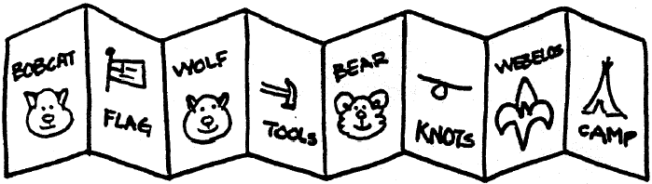
Use 5” x 7” cards that can be colored. Each boy makes drawing of a certain achievement or even a rank advancement. When all are done, then tape together to form an accordion look for the center of the tables.
Placemats
Baltimore Area Council
Even if you use paper tablecloths, placemats make the table look more festive. Here are some ideas for easy, fun placemats.
Marbleized
Equipment: White legal size paper, blue and gold paint, all equipment shown above. You can marbleize your placemats to match your invitations following the directions above and then have them laminated for the boys to take home and use again and again.
Waxed Paper Placemats
Equipment: Waxed paper, blue and yellow crayons, fruit peeler, iron Give each boy two pieces of waxed paper the size of a placemat. Shave pieces off blue and yellow crayons with a fruit peeler on one of the pieces of waxed paper and cover it with the other piece. Seal the paper and melt the crayon with a warm iron. Press slowly and uniformly.
Paw Prints Placemats
Equipment: Blue construction paper, potato, knife for carving, yellow poster paint Using a potato stencil (see Wolf - Elective 12) carved into a paw shape, cover a piece of deep blue construction paper with yellow paw prints.
Blue and Gold Twirlers
Santa Clara County Council
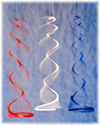
One way to show your Cub Scout colors is to hang an array of blue and gold twirlers at your Blue and Gold Banquet.
Supplies: Plastic coffee can lids, Marker, Scissors, String, Nail
Directions:
- Use a nail to poke a hole in the center of a plastic coffee can lid.
- With a marker, draw a spiral that starts 3/8 inch from the hole and gradually extends to the rim,
- Cut along the line with scissors.
- Knot an end of a piece of string, thread the other end up through the hole in the center, and the twirler is ready to hang up and spin.
- To spin, grasp each one at the bottom, twirl it around and around until the string is wound tight, let go and enjoy the show.
Blue and Gold Pin
Santa Clara County Council
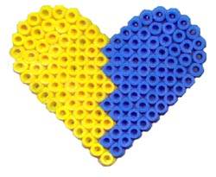
This is an easy to make craft, and the Moms will be proud to wear it. Adult supervision is recommended for ironing.
Supplies:
About 60 Blue Perler Beads,
About 60 Yellow Perler Beads,
Perler heart-shaped form,
Special ironing sheet (comes with the Perler beads),
Iron and ironing board, Hot glue gun, Pin backing
Directions:
- Look at the picture above for an idea on how to lay out your beads on the heart-shaped form.
- Iron the beads per the manufacturer's instructions.
- Let cool completely.
- Carefully peel off the heart from the form.
- Hot glue the pin back to the side of the heart that has been ironed on.
- Give to the Moms to wear to the Blue and Gold Banquet, or any Pack Meetings.
Mini Music Shakers
Santa Clara County Council
These are easy to make from empty film canisters and craft sticks.
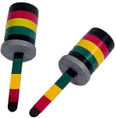
Supplies:
2 empty film canisters;
2 Craft sticks;
Colored vinyl tape;
Black marker or paint;
Rice, beans or beads;
Scissors
Directions:
- Paint the craft sticks black.
- Decorate the sticks and the containers using colored vinyl tape.
- Cut a slit in the tops to hold the craft sticks securely.
- Fill containers half full with rice, beans or beads.
- Replace the tops.
- Push in the crafts sticks.
3-Dimensional Star Centerpiece
Santa Clara County Council
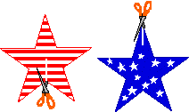
This 3-dimensional star decoration is made from 2 paper stars that are interlaced. These stars stand by themselves on a table, and make a great Blue and Gold Banquet table centerpiece.
Supplies:
Stiff paper (like card stock, oaktag or thin cardboard) or Styrofoam meat trays;
Scissors; Crayons or markers (optional)
Directions:
- Two paper stars are needed to make one 3-dimensional star. Either draw two identical stars on a piece of stiff paper or print out a star template.
- Decorate the two stars (if you like) on both sides, and then cut them out.
- Make one slit in each star. On one star, the slit goes from an inner corner to the center point of the star; on the other star, the slit goes from an outer corner to the center point.
- Slip the two stars together through the slits you just cut. For stability, you may have to tape the stars a bit where they meet at the slits.
Clothespin Cub
Baltimore Area Council
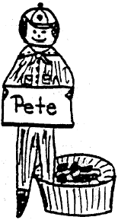
Paint a clothespin to resemble a Cub Scout. Cut out two paper arms, and glue them to the sides, facing outward. On a small piece of paper, print the boy’s name and glue the paper in the Cub’s hands. Glue the Cub to a cardboard circle securely, so that the Cub will stand erect. For a favor, you can tape the Cub to a nut cup with one leg in and one leg out of the cup. Serves as a nut cup and nametag. Make sure there are enough for parents and guest.
Egg Cup Corsages
Baltimore Area Council
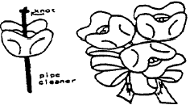
Use colored egg cartons if available, or otherwise use regular pulp cartons and paint with acrylic paint. Each flower is a section of an egg carton with the sides cut into rounded petals. Knot the end of a gold pipe cleaner and insert the other end through the center of the flower. This makes the flower center and also a stem. Combine several flowers by twisting stems, Finish with ribbon tied into a bow. Use a safety pin to pin to Mom.
Flag Placecard
Baltimore Area Council
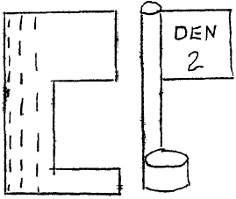
QUICK PAPER FLAGS can be made by folding a rectangular piece of construction paper in half. Crease then unfold. Cut out a section from one end. Decorate “flag area.” Roll the other end of the rectangle to form a flag pole. Next roll the base part to form a stand. Glue is applied to the last roll of the pole and to the end of the base. Use various of these quick flags to display historic flags or Den flag.
Write person’s name on the flag base.
Foam Ball
Great Salt Lake Council
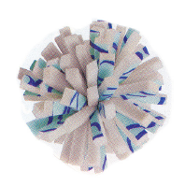
Material: 1 square foot of foam carpet padding, Permanent markers, 1 nylon zip tie, Pliers
Directions:
- To make your ball more colorful, draw some squiggly lines on the coated side of the foam and let dry.
- Use scissors to cut the foam into 24 strips, each a foot long by a ½ inch wide,
- Then cut each strip in half to make forty-eight 6-inch strips.
- Stack all the strips together and hold them tightly while another person wraps a nylon zip tie around the center of the stack.
- Use the pliers to pull the tie tight, and then snip off excess.
- If the ball is not spherical, use the scissors to trim
- it to your liking.
Tennis Ball Buddy
Great Salt Lake Council
Material:
Tennis ball any color Screw eye hook
2 pipe cleaners Craft foam any color
Fake fur 2 wiggle eyes
String Permanent marker
Tacky glue or hot glue gun Push pin
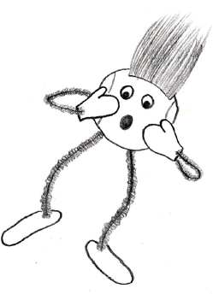
Directions:
- Use a push pin to make 4 starter holes in the ball for limbs,
- Then twist in a screw eye and remove it to enlarge each hole. Make another hole in the top of the ball but leave in the screw eye for the hanger.
- Cut 2 pipe cleaners in half and push the ends into the holes for the arms and legs.
- Cut hands and feet from the craft foam, poke the ends of the pipe cleaners through the shapes, and twist the pipe cleaners back on themselves to secure.
- Decorate using tacky glue or hot glue to attach wiggle eyes, fake fur, and other stuff. Draw with a permanent marker. Tie a string to the screw eye and hang where you want.
Patterns for Placemats or Masks
Baltimore Area Council
Enlarge this pattern to approximately 7 inches for masks
Even larger for Placemats
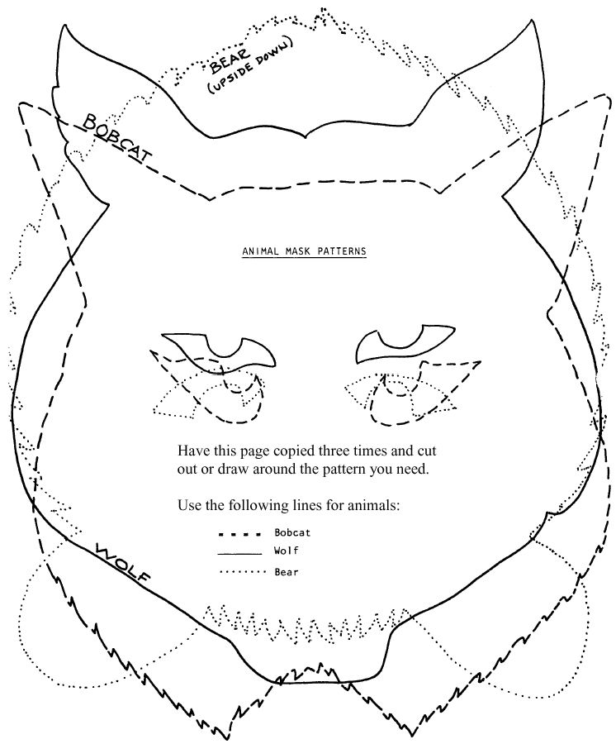
Buzzer
Cascade Pacific Council
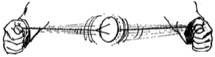
Use a large button or cut a disc from heavy cardboard. Thread a loop of strong string through the holes. Twist the cord a few times with a circular motion. Now pull your hands apart quickly, which will cause the disc to revolve. Then slack off as the disc slows, and it will revolve in the opposite direction. If you notch the edge, the disc will make a loud buzzing sound when it is revolving at high speed.
Go-zin-ta
Cascade Pacific Council
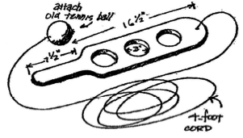
Cut out paddle from ⅜” or ½” soft wood. Make 3” holes separated about 1½” apart. Bevel the handle or sand smooth. Attach an old tennis ball to a strong, four foot cord and tie to the paddle. The object of the game is to toss the ball in the air and catch it in one of the holes.
Silhouette Scout Plaque
Cascade Pacific Council
You will need
construction paper
pencil
push pin
heavy cardboard
Directions
- Clip the pattern to a sheet of construction paper. Lightly print the appropriate name.
- Place a piece of heavy cardboard underneath for a working surface.
- Using a push pin, outline the pattern, pushing pin through each dot.
- Punch holes in the top comers, remove pattern, and add a yam hanger to plaque.
Pop Corn Centerpiece
Cascade Pacific Council

You will need:
1 #10 can
blue construction paper
yellow construction paper
light weight cardboard (arm and hands)
blue tempera or craft paint
white tempera or craft paint glue
plastic wrap
Cub Scout hat
construction paper (facial features)
yam or string
pop corn
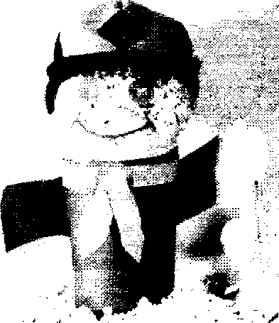
Sorry about the picture -
Just imagine

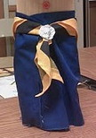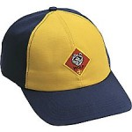
A Cub Body built a popcorn ball a Cub Scout
around the can decorated as a face hat on top
Assembly:
- Cover can with blue paper
- Cut a neckerchief out of the yellow paper and glue around can. Use a bread tag or something similar for a slide.
- Cut the hand and arms out of the cardboard. Paint arms blue and hands white (or glue blue paper over arms and trim to fit, repeat with hands - using white paper).
- Cover a 6" ball of popcorn with plastic wrap. (Cub Scout hat should just about fit the popcorn ball).
- Cut features from paper, and glue to front of face on the plastic wrap. Place hat on head.
- For added treats, make small popcorn balls and cover with wrap. Attach to hands with yarn.

"Pack Activities" are in the Pack and Leader Hints Edition Dave

DEN MEETINGS
Wendy, Chief Seattle Council

I have Wendy's info and will be incorporating it this week

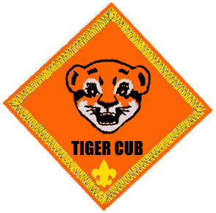

TIGER



WOLF
Letter from a Wolf Leader:
Donna, New Birth of Freedom Council (PA)
(I wish I could get many, many more letters like this one!! Donna - Thank you so much. CD)
For Cooking & Eating we recently made English muffin pizzas using a toaster oven since we don't have a kitchen at our meeting place. We also made ziploc ice cream http://www.grouprecipes.com/76755/ziploc-bag-ice-cream.html We talked about the food groups in each recipe we made, how pizza sauce wasn't enough to be considered a full veggie serving. I did write the ice cream recipe on a white board and made it obvious that I was using the recipe to know what I needed and the steps required. To save the den budget, parents contributed the supplies and ingredients.
I got totally carried away (took 2.5 den meetings) with Ach 5 - Tools for fixing and building. From a little less than 3 linear feet of a 1x6" each scout made a desk set. I mixed the fasteners so that we used nails, wood screws, and nuts/bolts/washers. Boys used hammers, sandpaper, screwdrivers, paint brushes and more. I attached a photo of a completed desk set. We also used elective 9b with the string-covered can as inspiration for the pencil holder portion of the desk set. The budget-saver this time: handy parents and grandparents who donated everything we needed except felt feet, glue and twine to cover the pencil cups/cans.
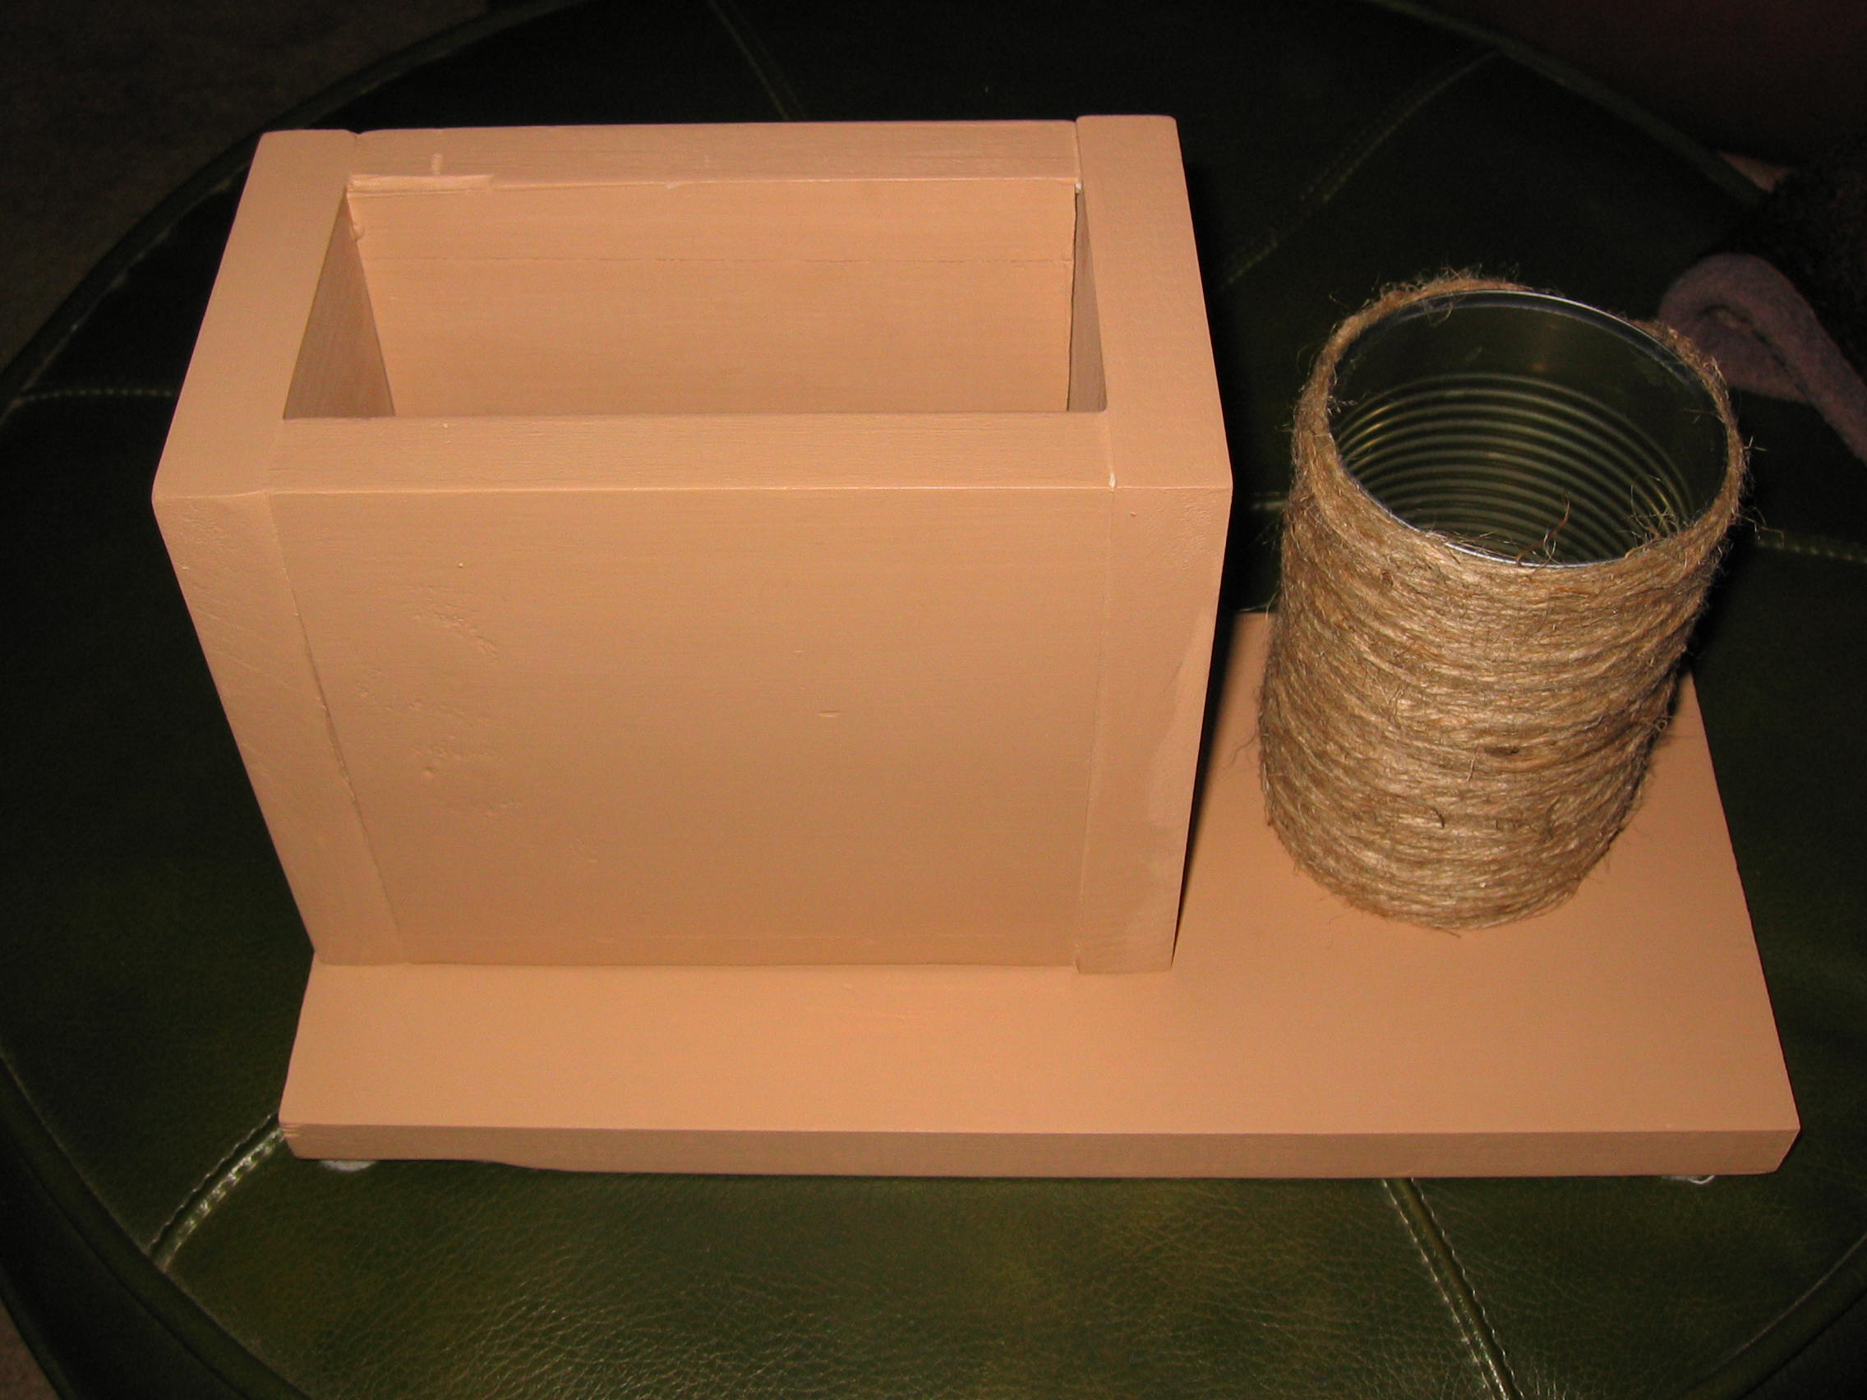
For Achievement 2g - I do a warm up with a double-sided paper flag. Folding a flag is confusing for many people. Letting the boys do it on a small scale first helps - you do need to skip the last lengthwise fold on paper otherwise it's too think to make the triangles. For November's pack meeting, each den presented a different activity, Wolves presented flag folding. Again, every family that could let us borrow a flag. At the pack meeting, we fortunately had Boy Scouts (some older brothers and some Den Chiefs) because the Tigers really needed help to keep the flag off the floor.
For Achievement 1 - any time the boys are getting a little wound up - I pick something from Achievement 1 to keep them busy during a transition to the next activity.
For Achievement 2b - we have flag ceremony at EVERY den meeting. I'm still explaining how it goes and coaching a lot but they're getting better.
For Achievement 4f - we visited the waste water treatment plant (when it was cold and NOT stinky - although they tell us it should not be stinky.) We have a scout whose family has been involved with scouting locally for about 17 years. They had never been to the WWTP.
For Achievement 9b/c - I assigned it as homework and we had a circle discussion (I have a wild bunch so we use a talking stick). One scout actually practiced escaping through the bedroom window and using his fire ladder. I personally got busted for keeping paper too close to the gas stove.
For Elective 23d - it was part of the instructions when we collected food for GTFA in November. Between Boy Scouts and Cub Scouts we collect door to door for the entire (small) town. Streets are assigned to each den (I don't know how the Boys Scouts do it - they just tell us our streets.) I then put two boys with their families together and they picked up food from several streets. If boys used a wagon (recommended) it also counted for elective 8b.
Every year the den carols at a low-income elderly housing development. We give every resident a small gift. This year we made bookmarks with scrap cardstock, beads and twine (leftover from the desk set project). Paper was my donation via my mother (sometimes it pays off to be a packrat.) Twine was tied with an overhand knot for elective 17e. And, since the boys gave the bookmarks to the residents, it also counts for elective 9b.

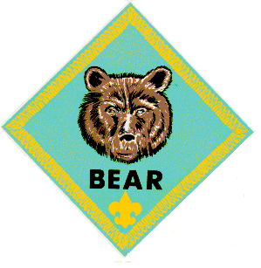

BEAR

WEBELOS DENS

Joe Trovato,
WEBELOS RT Break Out Coordinator
Westchester-Putnam Council
Have a question or comment for Joe??
Write him at
webelos_willie@yahoo.com
There is an underscore between Webelos and Willie

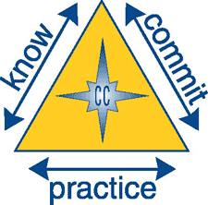

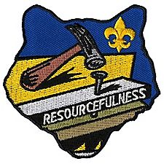

Core value for February
Resourcefulness

What is resourcefulness? The BSA says that it constitutes using human resources and other resources to their fullest. If we offer an opinion that someone is resourceful, it is usually because that person solved a problem that others failed to solve. Why are some scouts (and others for that matter) resourceful while other appear not to be? What are the elements of resourcefulness?

Necessity + Creativity + Persistence = Resourcefulness

I really don’t recall where I got the equation, above, but kept it in my files because I really think it explains, in clear terms how need, application and critical thinking play a part in success. Webelos have a wealth of opportunity to practice resourcefulness as part of their work on activity badges, belt loops and pins. Second year Webelos can bring resourcefulness in connection with their work towards the Arrow of Light. The Boy Scout Motto – Be Prepared - often requires resourcefulness when implemented. This month’s meeting activities on Handyman, Sportsman and Engineer provide ample opportunities for Webelos leaders to demonstrate how creativity and persistence solved a problem!

Does your Webelos den have a den flag, den yell, den doodle, and den name and emblem? Each of these may not only be used as a means to practice resourcefulness, but also build and maintain den cohesiveness and spirit!

What about activities outside the program items? Can you establish a “necessity” and then help guide your Webelos to be creative and persistent in order to resolve the matter? Perhaps have your Webelos come up with a project that presents a problem that needs a resolution.

Play some problem-solving games. Have boys create their own game. Here are a few you may want to try.

All Aboard

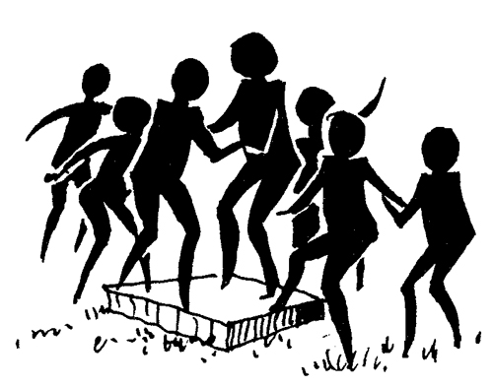

Webelos need to work together to solve the problem of keeping everyone on a space that keeps getting smaller. This activity can be done by forming teams of two to four people standing on small tarp, blanket or cardboard. The size should easily accommodate the number chosen for each team. The tarp, blanket or cardboard is then folded over and over again until it gets smaller and smaller. The teams will need to be resourceful in finding ways to stay on top of the tarp or cardboard longer than the other teams.
Mine Field
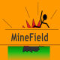

The minefield can be any space where various objects are scattered all over. This exercise works in pairs, in which one blindfolded Webelos scout is guided or given directions when going through the minefield. The other scout provides verbal directions on how to avoid the objects. Make some of the obstacles a bit difficult, so that the scout giving the directions will need to be creative in providing directions to the blindfolded scout.
Helium Stick
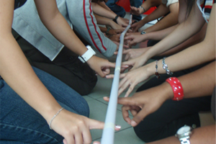

Form two lines facing each other. Lay a long, thin rod on the group's index fingers. Goal: Lower to ground. The catch: Each person's fingers must be in contact with the Helium Stick at all times. Pinching or grabbing the pole in not allowed - it must rest on top of fingers.
Reiterate to the scouts that if anyone's finger is caught not touching the Helium Stick, the task will be restarted. Warning: Particularly in the early stages, the Helium Stick has a habit of mysteriously 'floating' up rather than coming down, causing much laughter. Act surprised and ask what are they doing raising the Helium Stick instead of lowering it! For added drama, jump up and pull it down!
Some groups or individuals after 5 to 10 minutes of trying may be inclined to give up, believing it not to be possible or that it is too hard.
Eventually the a resourceful scout will take control and help the others concentrate, and very slowly, patiently lower the Helium Stick - easier said than done.
[Confidential: How does this work? The collective upwards pressure created by everyone's fingers tends to be greater than the weight of the stick. As a result, the more a group tries, the more the stick tends to 'float' upwards.]
Indoor Campfire
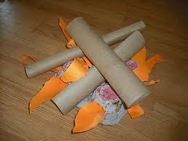

Finally, Webelos like “hands-on” activities. Have them build an indoor campfire for those times when they want a campfire setting, but can’t be outdoors. Have the scouts figure out material and method of construction and have it ready for use at the next pack meeting or perhaps use it as part of your Arrow of Light or Bridging ceremony.

You can find a number of plans for making indoor “campfires” that may be used to help the Webelos come up with their own idea. Here are two links to get you going:

http://www.ehow.com/how_5439779_make-fake-campfire.html

http://www.camppatmos.com/campfire/howtobuildacampfire.html

Book Corner

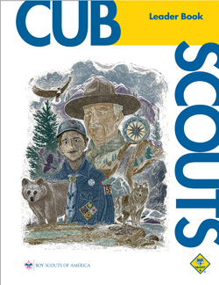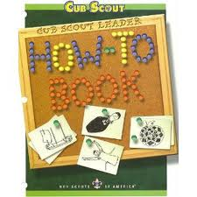

Check out page 4-4 of the Cub Scout Leader Book for practical applications of “resourcefulness” to your den activities. It contains a great quote that you can use: “There are those who look at things the way they are, and ask why? I dream of things that never were, and ask why not?”
—Robert F. Kennedy
http://www.scouting.org/filestore/hispanic/english/33221_WEB.pdf

Use the How-To Book’s many ideas to come up with great activities to help your Webelos scouts learn how to solve problems by being resourceful! Pages 1-3, 1-4 and 1-5 on Den advancement, den doodles and Den Flags may be a good resource. http://www.scouting.org/filestore/hispanic/english/33832_WEB.pdf

Meeting Planner

This month’s meeting plans for First year Webelos work on the Engineer badge.
Meeting 11: Engineer. Do: Engineer 2, 5, 6. HA: Review Engineer chapter
http://www.scouting.org/filestore/CubScoutMeetingGuide/webelos/WebelosMeeting11.pdf
Meeting 12: Engineer. Do: Engineer 1, 3, 4 HA: Review Craftsman chapter.
http://www.scouting.org/filestore/CubScoutMeetingGuide/webelos/WebelosMeeting12.pdf
Second year Webelos (Arrow of Light) work on Handyman and Sportsman.
Meeting 11: Handyman. Do: Handyman 1, 2, 5 – 8, 10 HA: Review Sportsman chapter
http://www.scouting.org/filestore/CubScoutMeetingGuide/ArrowofLight/ArrowofLightMeeting11.pdf
Meeting 12: Sportsman. Do: Sportsman 4 (Soccer belt loop) HA: Communicator 11-14 Review Communicator chapter
http://www.scouting.org/filestore/CubScoutMeetingGuide/ArrowofLight/ArrowofLightMeeting12.pdf

Flag Ceremony
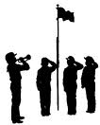
You should ensure that a formal flag ceremony be performed at your den meeting and at the monthly Pack meeting. I like adding something that is “month appropriate” to the basic ceremony. February provides us with President’s Day and the celebration of the birthdays of both Abraham Lincoln and George Washington. Include quotes or short passages about either or both presidents in the basic ceremony.

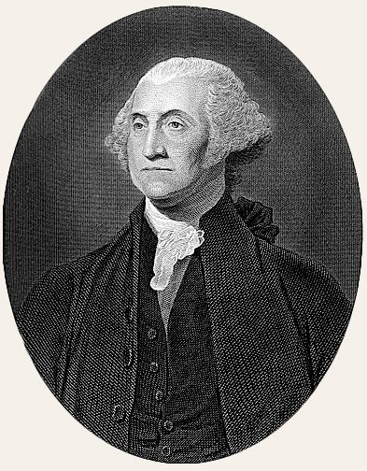 February Flag Ceremony 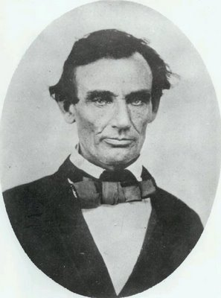
(Have the Three Webelos scouts offstage, ready holding the flags (the Color Guard). The US Flag is on the right, then State flag (if available), then Pack flag on the far left. Additionally, one Webelos scout acts as the Leader and two other flank the US and Pack flags as Readers.)
Leader: "Color Guard, Attention!"
Leader: "Audience, Please Rise!"
Leader: "Scout Salute! Those not in uniform, please place your right hand over your heart."
Leader: "Color Guard, Forward March!"
(Wait for color guard to reach the front)
Leader: "Color Guard, Halt!"
Leader: "Color Guard, Cross the Colors!"
(US Flag crosses in front of others to left-most flag stand, and then states, then troop flags. wait for flag bearers to move to the flag pole stands)
Leader: "Color Guard, Post the Flag of Pack 123!"
Leader: "Color Guard, Post the Flag of the Great State of [your state name]!”
(US Flag remains held by bearer)
Leader: "Please recite the Pledge of Allegiance!"
Leader: "TWO!"
(Everyone drops salute)
Leader: "Cub Scout Sign!"
(Everyone raises right hand making the Cub Scout sign)
Leader: "Please join us in reciting the Cub Scout Promise
Leader: "TWO!"
(Everyone drops Scout sign)
(This is where the ceremony can be customized by the color guard. Choose what to recite. The following is an example.)
Reader 1: George Washington was born on February 22, 1732. When he was born, America was not a nation yet. It belonged to England, a country across the ocean. People in America didn't want to belong to England so they fought a war to become a separate country. George Washington was an American general in the war. America won the war and picked a new name for itself: The United States of America. George Washington was elected to be its first President. A legend is told about George Washington as a boy. Young George had a new hatchet and with it he cut down a small cherry tree. When his father saw the tree, he was angry. "George," he said. "Did you do that?" George was afraid to admit that he did.
Nevertheless, the boy decided to tell the truth. "Yes, Father," he said, "I cut down the cherry tree with my hatchet. I cannot tell a lie." George Washington's father was proud of George for telling the truth.
Reader 2: Abraham Lincoln was born on February 12 in 1809. Things were different then. When Abe was a boy, he lived in a log cabin. A log cabin is a small house made out of logs cut from trees. His father cut down the trees and made the cabin.
There were no electric lights in the cabin. Young Abe read books by firelight and drew with charcoal on a shovel. Abe's family was poor. Often he went barefoot because he didn't have any shoes.
When Abraham Lincoln grew up, he studied hard and became a lawyer. Then he was elected to be a law-maker. In 1861, Abraham Lincoln became the 16th President of the United States.
Leader: "Color Guard, Post the Flag of the United States of America!”
Leader: "Color Guard, Honor your Colors!"
(Flag bearers salute the US flag)
Leader: "Color Guard, return to ranks!"
(Wait for flag bearers return to formation)
Leader: "Audience, Please be seated!"

Den Meeting Helpers
These activities can be used for the gathering or to reinforce/satisfy badge requirements.

Webelos


Engineer
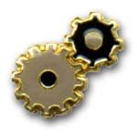
Engineer Ideas

- Draw a sketch of a bridge to build.
- Visit an office of civil engineers.
- Obtain a blue print of a building and ask an engineer to discuss the plans. Then tour the building.
- Visit a chemical production plant.
- Visit a college engineering department.
- Have an engineer visit your den and tell about his profession. He might be able to bring a set of blueprints, and explain the symbols used, and show how he uses blueprints.
- Visit The Corps of Engineers office if you are near one.
- Visit a bridge and take a tour.
- Measure the dimensions of your meeting place and include the location of doors and windows. Show how to sketch a simple floor plan with these measurements.
- Make catapults and have a contest. Demonstrate for the pack meeting.
- Have a resource person demonstrate the use of drafting tools.
- Visit a construction site with a contractor. Ask him to explain the use of blue prints and the order of construction.
- Have someone explain how to read topographic maps.
- Find pictures of different bridges and discuss the differences in their construction.

Fields of Engineering
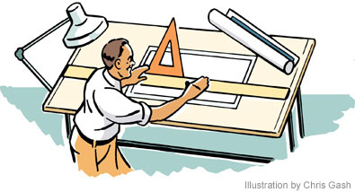

Aeronautical Engineering: Deals with the whole field of design, manufacture, maintenance, testing, and the use of aircraft both for civilian and military purposes.
Astronautical Engineering: Closely related to aeronautics, but is concerned with the flight of vehicles in space, beyond the earth's atmosphere, and includes the study and development of rocket engines, artificial satellites, and spacecraft for the exploration of outer space.
Chemical Engineering: Concerned with the design, construction, and management of factories in which the essential processes consist of chemical reactions.
Civil Engineering: Perhaps the broadest of the engineering fields; deals with the creation, improvement, and protection of the communal environment; providing facilities for living, industry, and transportation, including large buildings, roads, bridges, canals, railroad lines, airports, harbors, and other constructions.
Electrical Engineering/Computer Science: Divided broadly into the engineering of electrical power distribution systems, electrical machinery, and communication, information, and control systems.
Geological & Mining Engineering: Includes activities related to the discovery and exploration of mineral deposits and the financing, construction, development, operation, recovery, processing, purification, and marketing of crude minerals and mineral products.
Industrial or Management Engineering: Pertains to the efficient use of machinery, labor, and raw materials in industrial production.
Mechanical Engineering: Broadly speaking covers the design and operation of all types of machinery and small structures.
Safety Engineering: Concerned with the prevention of accidents.
Sanitary Engineering: A branch of civil engineering that has acquired the importance of a specialized field due to its great importance for a healthy environment, especially in dense urban population areas.

The Right “Man” for the Job!

Use a word from this list to fill in the correct answer.

Aeronautics, Chemical, Computer, City, Agricultural, Electrical, Physical, Industrial, Mechanical, Civil

1. An engineer who designs plants to make water safe to drink.____________________
2. An engineer who designs machines in a factory.______________________
3. An engineer who tests new processes and checks old ones in a chemical plant._______________
4. An engineer who plans new circuits and directs workers in an electrical plant.______________
5. An engineer who designs and tests new space techniques._________________
6. An engineer who designs and test new techniques for new equipment for industry.________________
7. An engineer who designs and tests equipment for farmers and ranchers.___________

The Different Types of Bridges:

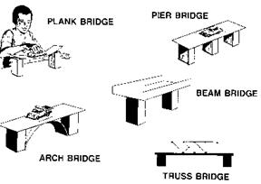
Beam Bridge: A beam bridge was derived from the log bridge. It is built from shallow steel beams, box girders and concrete. Highway overpasses, flyovers or walkways are often beam bridges. A horizontal beam supported at its ends comprises the structure of a beam bridge. The construction of a beam bridge is the simplest of all the types of bridges.
Truss Bridge: A truss bridge is built by connecting straight elements with the help of pin joints. Owing to the abundance of wood in the United States, truss bridges of the olden times used timbers for compression and iron rods for bearing tension. Truss bridges came to be commonly constructed from the 1870s to the 1930s. Deck truss railroad bridge that extends over the Erie Canal is one of the many famous truss bridges.
Arch Bridge: Going by its name, it is arch-shaped and has supports at both its ends. The weight of an arch-shaped bridge is forced into the supports at either end. The Mycenaean Arkadiko Bridge in Greece of 1300 BC is the oldest existing arch-shaped bridge. Etruscans and the ancient Greeks were aware of arches since long. But the Romans were foremost in discovering the use of arches in the construction of bridges. Arch bridges have now evolved into compression arch suspended-deck bridge enabling the use of light and strongly tensile materials in their construction.
Suspension Bridge: A bridge falling under this category is suspended from cables. The suspension cables are anchored at each end of the bridge. The load that the bridge bears converts into the tension in the cables. These cables stretch beyond the pillars up to the dock-level supports further to the anchors in the ground. The Golden Gate Bridge of USA, Tsing Ma Bridge of China and the Humber Bridge of England are some of the famous suspension bridges.
Cable-stayed Bridge: Structured similar to the suspension bridges, the difference lies in the amount of cable used. Less cable is required and consequently, the towers holding the cables are shorter. Two variants of cable-stayed bridges exist. In the harp design, cables are attached to multiple points of the tower thus making them parallel. In the fan variant of design, all the cables connect to the tower or pass over it. Cable Bridge boasts of being the first cable-stayed bridge of USA. Centennial Bridge is another well-known cable-stayed bridge.
Cantilever Bridge:
Cantilevers are the structures that project along the X-axis in space. They are supported only on one end. Bridges intended to carry lesser traffic may use simple beams while those aimed at handling larger traffic make use of trusses or box girders. The 1800 feet Quebec Bridge of Canada and the San Francisco-Oakland Bay Bridge that is 1400 feet long are some examples of the cantilever bridges.

Bridges and Machines

1. A flat surface over two supports _____________________
2. A flat surface over three or more supports__________________
3. A flat surface over an arched support__________________
4. A flat surface with turned up edges____________________
5. A bridge with sides made up of a series of triangles___________
6. A bridge that appears to hang from strong strung cables_______
7. A pulley(s) and a rope or cable_____________________
8. A slingshot or other device used to project something_________

Answers: Catapult, Pulleys, Beam, Bridge, Plank, Bridge, Truss, Bridge, Levers, Suspension, Bridge, Block and Tackle, Pier Bridge, Arch Bridge

MAKE A STEAM ENGINE
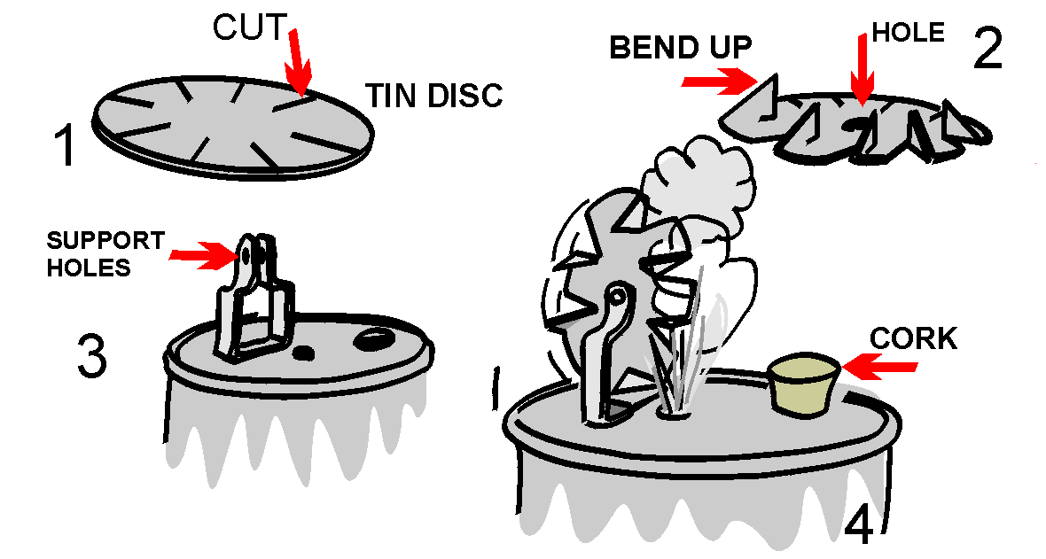
A Webelos Scout may get a graphic demonstration of the power of steam by building the simple steam turbine shown in this illustration. Materials needed are a tin can, a lid from a second tin can, a pair of tin snips, a sheet metal screw, a cork, a power drill, an extra piece of tin to make the support for the turbine wheel, a finishing nail, and a source of heat.
Engineer Word Search
Directions
Find the words in the puzzle that are listed below.
The words are horizontal, vertical, and diagonal, forwards and backwards.
All of the words are associated with the Engineer Activity Badge!
Put the unused letters in the boxes to find a hidden message!

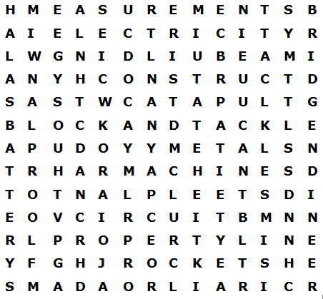
Hidden Message:
_ _ _ _ _ _ _ _ _ _ _ _ _ _ _ ! *

BATTERY COMPUTER MACHINE
CONSTRUCT BEAM MEASUREMENTS
DAMS BLOCK AND TACKLE METALS
BRIDGE ELECTRICITY PROPERTY LINE
BUILDING ENGINEER RAILROAD
CATAPULT FLOOR PLAN ROCKETS
CIRCUIT HIGHWAY STEEL PLANT
[* “ALWAYS STUDY HARD”]

Marshmallow Catapult Competition
Materials: one-cup milk carton, scissors, graph paper, one 2-inch rubber band per two scouts and other rubber band sizes as requested, toothpick, 2 pencils, tape, small match box (can be made from a 3 by 5 card and tape), mini marshmallows, hole punch.
Background: A catapult is a lever built specifically to throw something. They have been used since ancient times in warfare but have other useful purposes.
Competition: The competition phase can be done depending on your meeting place and interest. Accuracy or distance or both can be used. Explain the directions and how scoring will be done before the competition begins.
Safety suggestions: Goggles need to be worn while any scout is testing the catapults. Catapults may be tested only in designated "firing ranges" where projectiles go toward a wall with no one in their path. No unauthorized use of catapults.
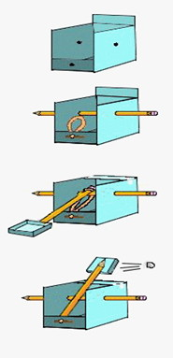
Mouse Trap Cars
Powered by a mouse trap - a mouse trap on wheels. The idea was conceived by some French Canadian Scouts from Ontario, and the instructions had to be translated from the French.
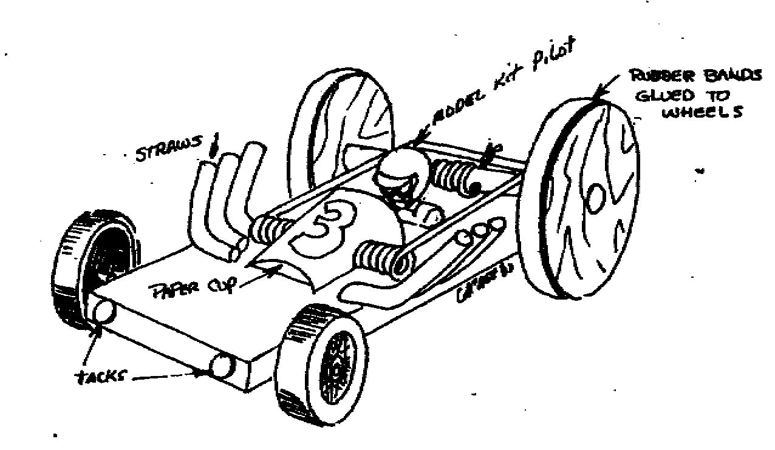

List of Material
Front wheels and axle
( Pinewood derby) 2 each
Mouse trap (Victor brand)
Wood block 1 3/4 x 4 3/4 x 1/2
Screw eyes 5/16- 2 each
Rear wheels S - 4-dia. 2 each
Dowel 1/4 x 4
Nylon string ,6
Remove the cheese holder and hook arm from the trap base.
Mount the trap on the base with the snapper to one end (as shown on the diagram above).
Carefully measure ½ in from the end of the base for the eyelets. Install eyelets so that the dowel axle turns freely.
Drill a 1/16in hole through axle (this is for winding the string).
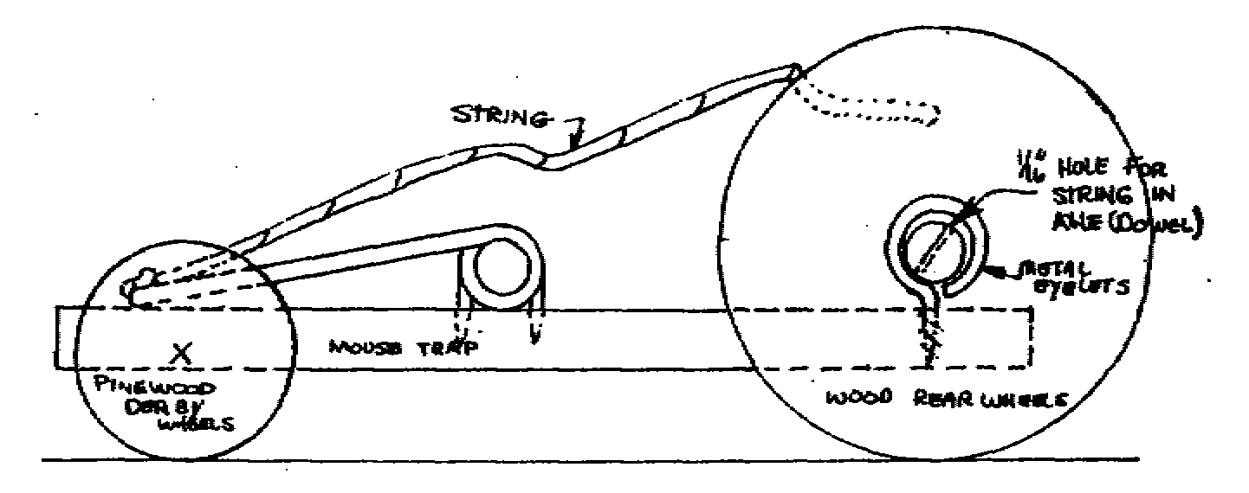
Mount rear wheels on the rear axle. Be sure that the wheels turn freely and do not bind against the body block. Spacers may be needed to aid in this. Front wheels - Remove any molding flash from wheels.
Carefully locate and drill guide holes for the front axle pins. Install wheels testing to make sure that they turn smoothly.
Tie a string about six inches long to the center of the snapper. This will then be fed through the hole in the rear axle.
To Operate:
Pull the snapper back to its full extent and hold with thumb. Slip the tip of the string through the hole in the axle and wind the wheels backward, winding the string around the axle.
Set the racer on the floor, not carpet, and release. The car should go at least 9 feet. If the string is too long it will wind around the axle and stop the car. Speed and distance can be increased by waxing the axle where it rubs on the screw eyes. Any other modifications that will give better operation and looks are up to you. HAVE FUN!!!

Gumdrop Truss Bridge
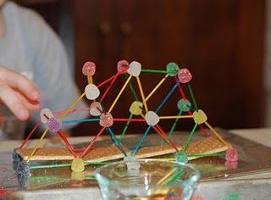
This is a fun project that not only illustrates the strength and rigidity of a truss bridge, but which the scout can eat (if they keep the bridge neat and clean)!
You will need a box of round toothpicks and a couple of bags of inexpensive gumdrops (or spice drops). Scouts can work as pairs or individuals on this project.
Each scout should start by assembling a single triangular panel using 3 gumdrops and 3 toothpicks. (It is important to notice the strength of the triangular shape.) From there they can extend the side panel of the truss by adding more toothpicks and gumdrops.
Once the single truss is about 4 panels long, the scouts can begin the second side truss. The two sides are then connected together by adding toothpicks between matching gumdrop node points.
This short bridge span, which is about 8 inches long, will be very stiff and strong. Spanning the bridge between two stacks of books, or the like can test the strength. A cup full of pennies can be used to load the truss. After testing the strength, the scouts can extend the bridge length by adding more pieces. A second level of truss may be added for really long spans (2 ft or more). The scouts will enjoy testing out various different bridge configurations.

Arrow of Light


Handyman


Handyman Ideas
- Have a clinic on the care and repair of bicycles. Set it up like a shop and have each boy bring his bike and do repairs, etc.
- Ask a cyclist to the den meeting to talk about proper care and maintenance of a bicycle.
- Have a bike inspection and bike rodeo.
- Invite someone from the local bicycling club to tell about the upcoming trips. Learn about the kinds of bicycles that are used.
- Visit a local bicycle shop and talk with the mechanic to see if he will show you how to do a safety check on your bike and perform minor adjustments.
- Organize a pack car wash.
- Visit a car wash facility.
- Visit a gas station, garage or tire repair shop.
- Have a family car inspection.
- Visit a service station. Ask an auto mechanic to show the different types of equipment they use. Watch a demonstration of preventative car maintenance.
- Arrange for a local mechanic to visit your Den or visit his garage, perhaps he can show your Den the safe way to change a tire, light bulb and to check the oil and transmission fluid.
- Hold a nail hammering contest. See who can hammer a nail in the fewest number of strokes.
- Show safety measures for lawn mowing.
- Build sawhorses and demonstrate their use.
- Go to a hardware store or garden nursery. See what hardware can be used to make a storage area for hand, lawn and garden tools.
- At a hardware store, visit the repair shop, and acquaint the Scouts with a few specific and varied sections in the store, like electrical supplies and hand tools.
- Arrange a presentation at a well-equipped home workshop.
- Check with the local fire marshal or poison control center to find out how to store household cleaners and materials that will be safe from small children.
- Check the garage or storage shed in your house to ascertain the tools or implements are properly and safely stored.
- Have Webelos bring tools to a Den Meeting and demonstrate different ways to mark them.
- Tour a hardware store or garden store. Look for ideas on how to set up a storage area for garden tools and hand tools.
- Visit a paint store and watch how colors are mixed. Look at the variety of brushes and the types of paint. Pick out a new color for your house and the trim.
- Tool demonstration: Meeting to be held in someone's workshop observing the use of various power tools. Talk about the safety precautions in a shop.
- Check with the local police department to see if they have a program called “operation Identification", or a program similar to this, and find out how to mark valuables in your home for identification.

Parent Checklist



Note: Because so much of this badge must be done at home it is suggested to alert the parents early. Use a requirements check off sheet such as the one below. Send it to the parents a week before the work begins on this badge, or send it home at the prior Pack meeting. Ask the parents to have the sheet returned by the Webelos Scout after completing all the “at Home” activities.
- With proper adult supervision, wash a car.
This requirement has been completed (parent please initial):___
- Help an adult change a tire on a car.
This requirement has been completed (parent please initial):___
- Replace a bulb in the taillight, turn signal, parking light, or headlight on a car.
This requirement has been completed (parent please initial):___
- Show how to check the oil level and tire pressure on a car.___
This requirement has been completed (parent please initial):___
- Make a repair to a bicycle, such as tightening the chain, fixing a flat tire, or adjusting the saddle or handlebars.
This requirement has been completed (parent please initial):___
- Properly lubricate the chain on a bicycle.
This requirement has been completed (parent please initial):___
- Properly inflate the tires on a bicycle.
This requirement has been completed (parent please initial):___
- Replace a light bulb in a fixture or a lamp.
This requirement has been completed (parent please initial):___
- Arrange a storage area for household cleaners and materials that will be safe from small children
This requirement has been completed (parent please initial):___
- Build a sawhorse or stool to be used around your home.
This requirement has been completed (parent please initial):___
- Mow a lawn and properly rake and dispose of the clippings.
This requirement has been completed (parent please initial):___
- Arrange a storage area for hand tools and lawn and garden tools.
This requirement has been completed (parent please initial):___
- Clean and properly store hand tools or lawn and garden tools in their storage area.
This requirement has been completed (parent please initial):___

Scavenger Hunt

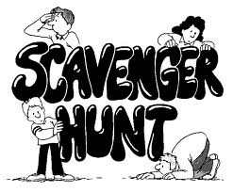

In a boy’s home or meeting place, hunt for the following items or create your own list. Boys should be accompanied by a leader or parent. They should not gather the items but instead, have the boys write down the location of each.

Here is a sample: Pruning shears, Edge trimmer, Lawn mower, Gasoline can, Oil can, File, Pliers,
Hammer, Nails, Screwdriver, Air pump, Tire tube, Old rags, Old newspapers, Window cleaning solution, Aluminum cans, Tire pressure, gauge, Crescent wrench, Tire changing tools, Auto jack and stand.

After the locations for these tools are recorded, go over the list and see if any of the items are not stored in the proper locations. For example, are the old rags stored on top or next to the gas can in a closed cabinet? Are the pruning shears lying on the floor where young children may be able to “play” with them? Also check the tools for cleanliness and sharpness. These factors influence their serviceability.

Kim's Games-Handyman Style

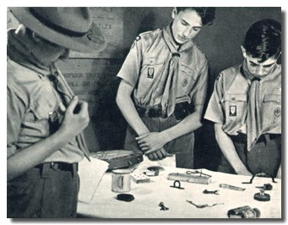

Collect 20 items used for household repair jobs - nail, washer, screw, nut, etc. Lay these items on a table or tray.

Let the boys have a good look, then cover items, or remove the tray. Each boy is to write down as many things as he remembers.

Game can also be played by team.

Tire Inflation Game

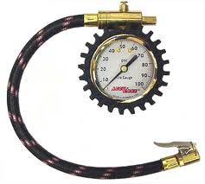

Divide Den into two teams. Have a bicycle for each team.

Each boy pumps up empty tire until he thinks it’s full as judged by his feeling the hardness of tire.

Leader checks with tire gauge to agreed upon full tire pressure.

Team with average pressure closest to correct full pressure wins.

Too easy? Add a time factor like maximum of one minute per scout.

Sportsman


Sportsman Ideas

- Explain and discuss football signals.
- Invite a referee or umpire to talk with the den about signals and/or sportsmanship
- Parents and boys attend a high school or college football game.
- Go bowling as a den or at a district tournament if possible (belt loop)
- Have each boy list the sports in which he participated during the past year
- Attend a high school football/baseball game.
- Go fishing (belt loop)
- Decide on a demonstration for the pack meeting
- Learn a new sport.
- Learn what two individual and two team sports the boys will want to do.

Micro Hockey



Use two cardboard boxes as the goals. Supply chopsticks and a checker for the puck.

Frisbee Baseball



Played according to regular baseball rules. The pitcher throws the Frisbee toward the "batter: who then catches it. If he misses it, it is a strike and if it is outside the strike zone, it is a ball. The "batter" who has made a good catch, then throws the Frisbee and proceeds around the bases. If it is caught the "batter" is out. The rest of the game follows baseball rules.

Name the NFL Team



Army insects _______________________
Seven squared _____________________
A 747_____________________________
Hostile attackers____________________
Helpers to relocate __________________
Various iron workers_________________
Sun tanned bodies __________________
I.O.U.’s __________________________
Toy baby with fish arms ______________
Trained to kill ______________________
Lubricators ________________________
Six rulers _________________________
Opposite of ewe ____________________
Class of Boy Scouts _________________
American Gauchos__________________
Loyal Team ________________________
Credit card users ____________________
Indian leaders ______________________
King of beasts ______________________
Team of tigers ______________________
A dollar for corn _____________________
Ocean going bird ____________________
Hot epidermis _______________________
Six shooters ________________________
Rodeo horses _______________________
Heavenly team ______________________
Grumpy person______________________
Game at Al’s ________________________

Teams:
Giants, Jets, Packers, Browns, Dolphins, Oilers,
Rams, 49’ers, Cowboys, Patriots, Raiders, Chargers,
Chiefs, Steelers, Lions, Bengals, Bills, Bears,
Buccaneers, Seahawks, Falcons, Redskins, Colts, Vikings, Eagles, Broncos, Saints, Cardinals

OLYMPICS FOR A RAINY DAY



Shot Put - Each boy is given 10 navy beans, which he attempts to throw into a quart jar from a chalk line on the ground.
Discus - Throw a paper plate is thrown from a chalk line. Plate must be held flat in hand and not sailed with thumb and fingers.
Twenty Foot Dash - Roll lemons or hard boiled eggs down the course and back, touching off the next man. Use a stick to roll the object.
Fluff - Carry feathers on a plate. Boy must pick up any that drop and start over.
Bean Relay - Carry beans one at a time between matchsticks or toothpicks to opposite end of the course.
Balloon Blowing - Give each boy a balloon to be blown up. First balloon to break wins.

HIDDEN SPORTS EQUIPMENT

Find the 18 hidden pieces of sports equipment in the picture below.

soccer ball - bowling ball - bowling pin - hockey stick and puck - croquet mallet - tennis racket - ice skates - roller blades – basketball – marbles – football – badminton – birdie - catcher’s mitt - golf club and ball – baseball - table tennis paddle

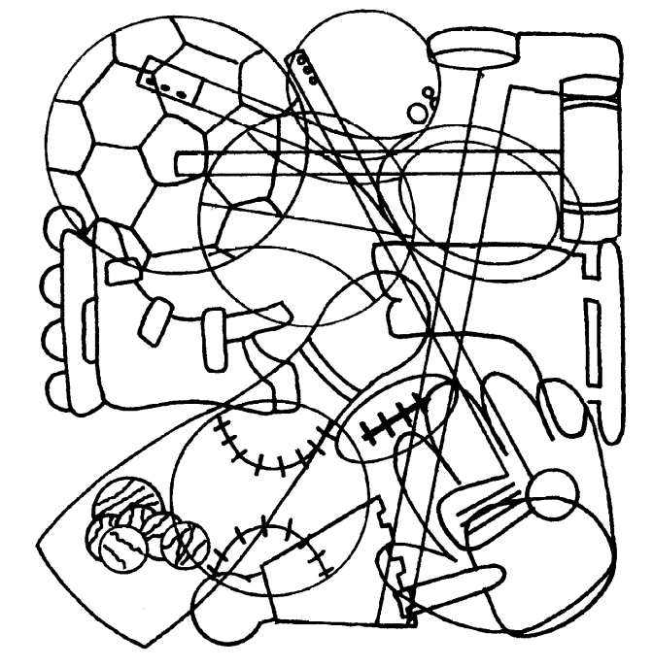

MARBLE GOLF

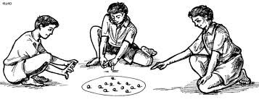

Set up this game and practice playing it for a future den or pack marbles tournament. For holes, bury baby food cans to the brim in the earth. Flags are paper triangles glued to craft sticks. Add water hazards and sand traps as you wish. Shots are taken in the approved knuckles down way for regular marbles. Winner is the Webelos who takes the fewest shots to get all the way around.

Soccer Belt Loop
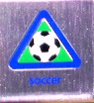
Complete these three requirements:
- Explain the rules of soccer to your leader or adult partner.
- Spend at least 30 minutes practicing soccer skills.
- Play a game of soccer.

ADDITIONAL ADVANCEMENT IDEAS
Alice, Golden Empire Council
Someone wrote and asked me why Alice and I have this section with all the advancement in the new Resource Book. These are additional ideas. Maybe your Cubs did some advancement in camp and you got to skip a section. Maybe your den is above average and streaking through the program. Maybe you want some ideas to tie into the Core Value of the month. Maybe your presenter or field trip for that week fell through and you need a Plan B. Here are ideas you can use!! CD and Alice

This section will be added when I hear from Alice.

CUB GRUB
Cub Grub
Number Salad
Cascade Pacific Council
Ingredients
One handful shredded coconut
Two tablespoons of orange juice concentrate
Three orange slices
Four apple slices
Five cubes of cheese
Six banana slices
Seven melon pieces
Eight grapes
Directions
Stir Nine times and eat.
Monkey Shine Shake
Cascade Pacific Council
Ingredients
1 ripe banana
1 cup milk
½ cup vanilla frozen yogurt
Directions
Peel banana and cut into pieces. Blend ingredients in a blender or in a two quart bowl with a mixer. Serve chilled.
Purple Cow Shake
Cascade Pacific Council
Ingredients
1 can frozen grape juice concentrate
1 cup milk
2 cups vanilla ice cream
Directions
Blend ingredients in a blender or in a two quart bowl with a mixer for about thirty seconds. Serve immediately.
Pretend Soup
2 c. orange juice
½ c. plain yogurt
1 Tbsp. honey
2 tsp. lemon juice
1 banana, sliced
1 c. berries, your choice
Directions
If frozen berries are used, defrost them first and use any juice with other liquid ingredients. Put orange juice, yogurt, honey and lemon juice in a bowl and mix well (a whisk works well for this). Divide banana slices and berries into four bowls, and ladle “soup” over the top.
Silly Salad 1
Cascade Pacific Council
Ingredients
Eyes: raisins
Ears: carrots or almonds
Mouth: cinnamon candy or cherry
Nose: raisin
Tail: marshmallow or cottage cheese
Body: pear halves
Directions
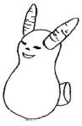
Silly Salad 2
Cascade Pacific Council
Ingredients
See picture below
Directions
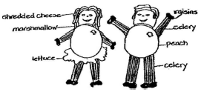
Ants on a Log
Cascade Pacific Council
Ingredients
Celery stalks, cut into 4” pieces
Peanut butter
Raisins
Directions
Fill the inside of the celery sticks with peanut butter. Top with three or four raisins each.
No Cook Fudge
Cascade Pacific Council
Ingredients
½ gal. heavy Ziploc-type bag
½ c. cocoa
3 oz. cream cheese
1 lb. powdered sugar
3 Tbsp. butter
1 tsp. vanilla
Directions
Place all ingredients in bag. Work out some air, then close tightly. Knead bag for twenty-five to thirty minutes. Nuts or peanut butter may be added.

POW WOW EXTRAVAGANZAS
Southern NJ Council
Improving Your 'Scoutability"
Postponed - University of Scouting under development

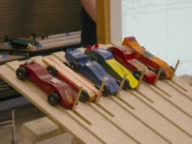

WEB SITES
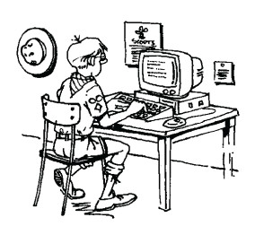
Great Scout Sites
Great Salt Lake Council
http://www.scouting.org/scoutsource/CubScouts.aspx
http://www.boyscouttrail.com/cub-scouts/cub-scouts.asp
http://www.scoutingthenet.com/
http://usscouts.org/bbugle.asp
http://www.cubmaster.org/
http://meritbadge.org/wiki/index.php/Cub_Scout_Leader_Portal
http://www.macscouter.com/
http://www.makingfriends.com/scouts/scouts_boys.htm
http://crafts.kaboose.com/cub-scout/
http://www.boyscouttrail.com/cub-scouts/tiger-scout-activities.asp
http://www.google.com/imghp?hl=en&tab=wi –
Search for “cub scout coloring pages”
http://www.activity-sheets.com/scout/camp-coloring/index.htm
http://coloringbookfun.com/scouts/
http://coloringpages.nick-magic.com/boyscouts.html
http://www.artistshelpingchildren.org/popsiclesticksartscraftsideascraftstickskids.html
http://www.etowahcreek.com/slides.htm
http://www.boyscouttrail.com/content/activity/tiger_neckerchief_slide-1471.asp
http://scienceshareware.com/lilivw/cub-scout-neckerchief-slides.htm
http://cubclub.tripod.com/
http://cubclub.tripod.com/craft.html
Introduction to poster and banner making
Great Salt Lake Council
There are two basic ways to create a printer with your letter-sized home printer. The first is to print out large letters or pieces or words and very big pictures, and use scissors and tape to place your individual printouts on a blank piece of poster board until it looks the way you want it too. It works, but it’s so last century!
The easiest method is to have software automatically split up a printout into multiple sheets that are easily taped back together to form a great looking poster. The question is where to find that software.
Most HP printers have a printer driver with a poster print option. Check your printer to see if you already have the capability.
Another method is to download a poster printing program. There are quite a few that are more than happy to charge you anywhere from $5 to $60 for their software. I have found a few options that are free (freeware). Most work well, but each has their own quirks. Try them out, and don’t be afraid to uninstall a program and install another if your needs are not met.
Easy Poster Printer 2.0.1.0
http://www.freewarefiles.com/Easy-Poster-Printer_program_54954.html
PosteRazor 1.5.2
http://www.freewarefiles.com/PosteRazor_program_18358.html or
http://www.snapfiles.com/downloads/PosteRazor/dlPosteRazor.html
Posteriza 1.1.0
http://www.all-freeware.com/download/36094/posteriza.html or
http://www.download3000.com/download_9314.html
Poster Forge
http://www.sharewareconnection.com/poster-forge.htm
The Big Picture v1.0
http://www.afterdawn.com/software/desktop/printing/the_big_picture.cfm
Clip Art for Posters
http://www.scoutingbsa.org/Council_Training/Join_Scouts/2002/ClipArt.html
http://clipart.usscouts.org/library/
http://www.scoutingthenet.com/Resources/Clipart/
http://www.graphmaster.org/
http://www.gccbsa.org/Pages/CA_Misc_Cub_Scout.html
http://www.scoutsonline.com/asp/bsaClipart.asp
http://www.glcscouting.org/ClipArt/index.html
http://teacherlink.ed.usu.edu/tlresources/clipart/scoutpict.html
http://clipart.cherokeescouting.org/gif.htm
http://sne.tripod.com/clip.htm
Poster Fonts
http://macscouter.com/fonts/
http://www.scouter.com/compass/Graphics_and_Clipart/Fonts/

More "Web Sites" are in the Pack and Leader Hints Edition Dave

ONE LAST THING


